MOBBERLEY
PARISH COUNCIL

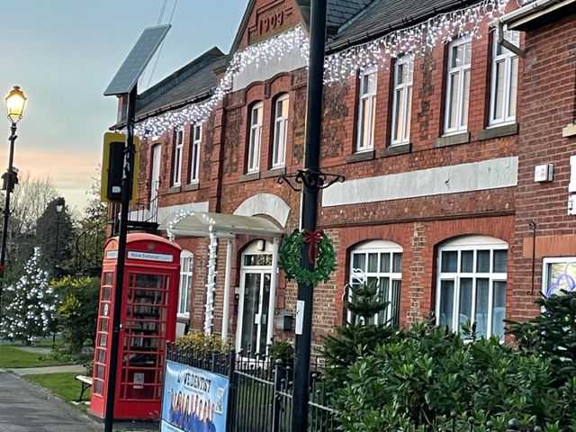

COMMUNITY RESILIANCE EMERGENCY PLAN

REMEMBER in the event of an Emergency Situation
Dial 999

www.cheshireeast.gov.uk
www.mobberleyparishcouncil.co.uk
Contents

Distribution List 3
Plan Amendment List 4
1 Introduction 5
2 Purpose of the Plan 6
3 Local Risk Assessment 8
4 Activation Triggers 11
5 Emergency Co-ordinators Contact List 13
6 WhatsApp Group for Emergency Coordinators 13
7 Emergency Organisations Contact List 14
8 Community Resources 16
9 Key Locations 18
10 List of Community Organisations 19
Appendix A - Emergency Action Check List 21
Appendix B - Community Emergency Meeting 22
Appendix C - Community Emergency Group Meeting Agenda 23
Appendix D - Agreed Actions with CEC in the event of an evacuation 24
Appendix E - Emergency Log Sheet 25
Appendix F - Map of Mobberley Parish 26
Appendix G - Location of Notice Boards and Defibrillators 27

Distribution List

 | Address | Type of Copy
1 | Mobberley Parish Council, Rajar Building, Town Lane, Mobberley | Paper
2 | Cheshire Constabulary,  Police Station, Toft Road Knutsford WA16 0PA | Sent via CEC JCEPT
3 | Cheshire Fire and Rescue Service,  Knutsford Fire Station, Mobberley Road, Knutsford WA16 8EX | Sent via CEC JCEPT
4 | Cheshire East Council, Emergency Planning Team, Westfields, Middlewich Road,  Sandbach CW11 1HZ | Resilience Direct
5 | Central & Eastern Cheshire Primary Care Trust, Universal House, ERF Way, Middlewich, CW10 0QJ | Resilience Direct
6 | North West Ambulance Service NHS Trust, Elm House, Belmont Grove, Anfield, Liverpool, L6 4EG | Resilience Direct
7 | Annandale Medical Centre,  99 Town Lane, Mobberley WA16 7HH | Email
8 | Toft Road Surgery, Toft Road  Knutsford WA16 9DY | Email
9 | Manchester Road Surgery, Manchester Road,  Knutsford, WA16 0LY | Email
10 | Mobberley Methodist Church, Faulkner's Lane  Mobberley WA16 7AJ | Email
11 | St Wilfred Church, Church Road, Mobberley WA16 7RA | Email

Plan Amendment List
This document will be reviewed annually at the Annual General Meeting of the Mobberley Parish Council or when significant changes have taken place that would affect its operation

Issue | Date of amendment | Details of changes made | Changed By
V1 | June 2023 | Transfer onto new template and update. | Kate Marsh
V2
V3
V4
V5

1 Introduction

Mobberley Parish Council may have an important role in both the response to and recovery from an emergency situation.

It is possible that the Parish Council may be able to act faster than many of the responding agencies as they have an in-depth local knowledge that would provide invaluable assistance to the response.

By completing a Community Resilience Plan the Parish Council is putting arrangements in place to mobilise resources that already exist in the Mobberley community to support residents during an emergency.

During a major wide area emergency, it could be some time before responding organisations are able to offer assistance. By planning in advance, the Parish Council could provide key assistance co-ordinating local response activities.

2 Purpose of the Plan

2.1 Aims
The aim of the Community Plan is to increase short term Community Resilience in response to an Emergency occurring in the local area

Definition of Community Resilience:
‘Communities and individuals harnessing local resource and expertise to help themselves in an emergency, in a way that compliments the response of the emergency services’

2.2 Objectives
- To enable the Community to respond effectively to an Emergency that occurs in the local area.
- To identify resources and key contacts within the Community that can assist the emergency services and Local Authority in the response to an Emergency.
- To identify Hazards and possible Mitigation measures within the community.
- To identify vulnerable people within the community

2.3 Roles and Responsibilities
- The Parish Council and other involved local bodies are committed to delivering this plan for the benefit of residents in the Parish. However, it should be noted that this support will be delivered by local volunteers. Those volunteers delivering the support will endeavour, subject to their skills and availabilities, take all reasonable measures to achieve the plan objectives.
- The role of the Parish Council is initially to use reasonable actions to ensure that the Emergency Services have been alerted to a potential incident and to establish contact with the Joint Cheshire Emergency Planning Team.
Once the Emergency Services have been contacted - provide information, to those bodies to help them establish the nature and scale of the emergency. The Community Emergency Group will help the Emergency Services to identify impacted and vulnerable individuals.
After the event - to liaise with residents, Emergency Services and any other involved participants to learn from the experience and determine what worked and what can be improved on.
- To maintain and update the plan based on latest requirements, lessons learnt, changes of contacts etc and good practice.

2.4 Scope
This Resilience Plan has been developed to support the Emergency response to Community wide Major Incidents rather than individual household issues.

A Community wide event can be characterised as:
- An event that affects typically multiple households, be it associated with people, their properties, access to them or the services they use.
- Requiring the engagement of multiple Emergency Services such as Police, Fire, Utilities or Cheshire East Emergency response.
- Beyond the capacity of any one household to resolve.
- Caused by an event from outside the property, such as flood water entering from outside the property.

It does not include:

- Individual households, unless there are some extenuating circumstances, such as the people impacted are classed as vulnerable; the cause is by circumstances out in the wider Community environment.
- Health matters, unless required by Cheshire East Council or the Emergency Services.
- General short-term operational failures to access utilities or services such as typical power outage

3 Local Risk Assessment

Risk | Impact on community | Preparation
Aircraft Incidents | - Potential loss of life.  - Major disruption to infrastructure.  - Potential homelessness. | - Identify evacuation premises at all parts of the Parish.  - Identify premises for forward control use by the Emergency Services.  - Identified premises for Rest Centre and inform Joint Cheshire Emergency Planning Team.
Train Crash | - Potential loss of life.  - Potential temporary evacuation of residents.  - Potential disruption to infrastructure. | - Identify premises for forward control use by Emergency Services.  - Identify vacant / suitable industrial premises for temporary use.  - Identified premises for Rest Centre and inform Joint Cheshire Emergency Planning Team
Floods | - Potential homelessness. | - Identified premises for Rest Centre and inform Joint Cheshire Emergency Planning Team
High Winds | - Structural damage to buildings and residential property, roads blocked.  - Potential temporary evacuation of residents.  - Potential homelessness.  - Urgent need to make buildings and property safe. | - Identify premises for forward control use by the Emergency Services.  - Identified premises for Rest Centre and inform Joint Cheshire Emergency Planning Team  - Prepare list of local building contractor.
Chemical Spill / Explosion / Fire | - Potential structural damage to buildings and residential property.  - Atmospheric pollution. | - Identify premises for forward control use by the Emergency Services.  - Prepare list of local building contractors.  - Contact Environment Agency.
Gas Pipeline Explosion – Oil line | - Potential loss of life.  - Possible homelessness.  - Potential structural damage to buildings and residential property.  - Loss of infrastructure. | - Identify premises for forward control use by the Emergency Services.  - Identified premises for Rest Centre and inform Joint Cheshire Emergency Planning Team  - Prepare list of local building contractors.
Air Pollution | - Breathing problems | - Identify vulnerable residents.  - Coms messages on local Social Media platforms. Follow Public Health advice to keep residents indoors, close windows.
Subsidence | - Potential structural damage to buildings and residential property.  - Possible homelessness | - Identified local B&B.  - Prepare list of local building contractors.  - Contact structural engineer.
Severe snow fall and icy conditions | - Housebound vulnerable residents unable to obtain supplies. | - Identify housing occupied by vulnerable residents.  - Contact CEC for list of vulnerable residents.  - Prepare list of voluntary agencies and community groups who may deliver essential supplies.  - Check gritting routes with CEC on twitter or CEC webpage.
Major Traffic Incident M6 / A556 | - Heavy slow-moving traffic using smaller Parish B roads.  - Residents unable to gain access to road network. | - Identify suitable accommodation for stranded motorists if required / requested.  - Identify local cafes for refreshments for stranded motorists if required.
Animal Disease, e.g. foot and mouth | - Closure of some footpaths | - Identify local footpaths  - Maintain contact with CEC representatives.
Livestock on main roads | - Disruption to traffic flow. | - Contact Burly Man  - Contact Vet or Police if injured animal
Pandemic | - Disruption to amenities, impact on local business. | - Revert to online meetings to reduce interaction.  - Identify housing occupied by vulnerable residents.  - Contact CEC for list of vulnerable residents.  - Prepare list of voluntary agencies and community groups who may deliver essential supplies.
National Power Outage | - Potential temporary evacuation of residents.  - Potential loss of life  - Loss of infrastructure.  - Disruption to amenities, impact on local business  - Housebound vulnerable residents unable to obtain supplies | - Identify buildings with back-up generators to use as Rest Centre.  - Identify vulnerable people  - Identify water and food supplies.
NOTE - CEC have Rest Centre / Evacuation plans in place. Contact JCEPT

Key Locations section 9
Local Contractors section 8
List of Community Groups section 10
Emergency Contacts section 7

4 Activation Triggers
This Plan can be activated by the following means and action taken as indicated:

Source | Action to be taken
A telephone call from any of the Emergency Services or Joint Cheshire Emergency Planning Team  to  Mobberley Council or to the Mobberley Emergency Community Co-ordinator / Deputy Emergency Community Co-Ordinator. | - Take a detailed note of the nature of the emergency and any request for immediate assistance.  - Make a note of the organisation, name, address, and telephone number of the caller.  - Activate the “WhatsApp Group for Emergency Coordinators” if appropriate.  - Emergency Community Co-ordinator to set up a command post at Rajar Building or, if that is not safe, at another appropriate Key Location.  - Inform Emergency Services and Joint Cheshire Emergency Planning Officers of the location and contact numbers of the agreed Mobberley Command Post.  - Take appropriate action as requested by the Emergency Services and or Joint Cheshire Emergency Planning Officers.
A telephone call from a member of the public direct to Mobberley Parish Council  but  no communication possible with Emergency Services or Emergency Planning Team. | - Take a detailed note of the nature of the emergency and any request for immediate assistance.  - Make a note of the name, address, and telephone number of the caller.  - Make sure you take a direct telephone number for the caller.  - Convey this information to the Emergency Community Co-ordinator who will activate the “WhatsApp Group for Emergency Coordinators” if appropriate.  - Emergency Community Co-ordinator to set up a command post at Rajar Building or, if that is not safe, at another appropriate Key Location.  - Emergency Community Co-ordinator to take all appropriate action until communication can be made with the Emergency Services who will thereafter take control of the incident. This to include, if necessary, the calling of a Community Emergency Meeting (appendix B)  - Take appropriate action as requested by the Emergency Services and Joint Cheshire Emergency Planning Officer.

5 Emergency Co-ordinators Contact List
In the event where the Emergency Community Co-ordinator or deputies cannot be contacted the clerk of the Parish Council will assume the role of Emergency Community Co-ordinator.

Title | Name | Contact Details | Address
Emergency Community  Coordinator | Cllr David Brush | d.brush@mobberleyparishcouncil.co.uk | Contact Mobberley Clerk
Deputy Emergency Community  Coordinator (1) | Cllr Janet Cookson |  | Contact Mobberley Clerk
Deputy Emergency Community  Coordinator (2) | Cllr Susan Bellamy |  | Contact Mobberley Clerk
Mobberley Parish Council Clerk  Co-ordinator (3) | Kate Marsh | 01565 872333  clerk@mobberleyparishcouncil.co.uk | Contact Mobberley Clerk
Cllr Hannah Moss (4) | Cllr Hannah Moss | hannah.moss@cheshireeast.gov.uk | Contact Mobberley Clerk

6 WhatsApp Group for Emergency Coordinators

A WhatsApp group has been set up which includes the 5 Co-ordinator’s listed in part 5. In the event of an emergency, the WhatsApp group will be used to pass information between the Co-ordinators.

Note: In the event of a breakdown in communication using the WhatsApp group, Cllr David Brush is the nominated person assigned to ensure that all necessary information is passed on. In the absence of Cllr Brush, Cllr Cookson shall be the responsible office.

7 Emergency Organisations Contact List

Service/Role | Contact Details | Address
Emergency Services | 999 or 112
Emergency Coordinator  Cllr David Brush |  | Contact Mobberley Clerk
Deputy  Emergency Coordinator (1)  Cllr Janet Cookson |  | Contact Mobberley Clerk
Deputy  Emergency Coordinator (2)  Cllr Susan Bellamy |  | Contact Mobberley Clerk
Mobberley Parish Clerk (3)  Kate Marsh | 01565 872333
Cheshire East Council | 0300 1235500  or  0300 1235025 (OOH) | Westfields, Middlewich Road, Sandbach, CW11 1HZ  www.cheshireeast.gov.uk
Joint Cheshire Emergency Planning Team (Office link) | 0845 1249830 (OOH) | Westfields, Middlewich Road, Sandbach, CW11 1HZ  emergencyplanningteam@cheshirewestandchester.gov.uk
Cheshire Police | 101  Non-Emergency | Toft Road  Knutsford  WA16 0PA  www.cheshire.police.uk
Cheshire Fire and Rescue | 01606 868700  Non-Emergencies | Headquarters Sadler Road Winsford, CW7 2FQ www.cheshirefire.gov.uk
Cheshire Fire and Rescue | 01606 868924 | Knutsford Fire Station, Mobberley Road, Knutsford WA16 8EX
Macclesfield Community Hospital | 01625 421000 | Victoria Road, Macclesfield, SK10 3BL
E.A. - Flood line | 0345 9881188 | www.environment-agency.gov.uk
E.A - Environment Incident Hotline 24hr | 0800 807060 | www.environment-agency.gov.uk
National Grid - Gas | 0800 111999 | www.nationalgrid.com/uk/
National Grid - Electricity | 0800 404090  Emergency 105 | www.nationalgrid.com/uk/
United Utilities Emergencies | 0345 6723723 | www.unitedutilities.com/
Network Rail | 0845 7114141 | www.networkrail.co.uk

8 Community Resources
Note: The inclusion of private organisations in this list does not imply that Mobberley Parish Council endorses or recommends any of the services provided by those organisations.

Resource  (Inc. details) | Contact Details |  | Location |  | Capability
Hotels and Bed & Breakfast Accommodation
The Hinton  Guest House |  | 01565 873484  ann@thehinton.co.uk |  | Town Lane  Mobberley  WA16 7HH |  | 1 Single  2 Double  2 Twin  1 Family suite  1 King size room
Laburnum Cottage Guest House |  | 01565 872464  Info@laburnumcottageguesthouse.co.uk |  | Laburnum Cottage, Knutsford Road Mobberley  WA16 7PU |  | 2 family rooms  3 double rooms  2 single rooms
Travel Lodge |  | 08719 846484 |  | Wells Road,  Northwich, CW9 7UA |  | Accept up to 2 dogs
Electrical Contractors
Evolution Electrical Services |  | 01565 873085 |  | Miller Cottage, Slade Lane, Mobberley. |  | Domestic, Industrial and Commercial
Canute Electrical |  | 01565 873365 |  | 3 Townfield Road, Mobberley. |  | Domestic, Industrial & Commercial
Tree Surgeons, Fencing & Wood Products
Bartlett Tree Service |  | 01565 632445 |  | Chelford Road  Knutsford |  | Tree Surgeon
Foden Lane Nurseries |  | 01477 549780 |  | Foden Lane Alderley Edge
Plumbers
Derek Royle |  | 01565 873791 |  | Moss Croft Farm Moss Lane Knutsford
Builders
J.A. Bingham Ltd |  | 01565 872597 |  | Croft Cottage Hobcroft Lane Mobberley
Roofing Companies
K.J. Keogh Roofing |  | 01565 650278 |  | Parkview, Mobberley Road Knutsford |  | Roofing Contractors
Veterinary Surgeons
Ark Veterinary Surgery |  | 01565 872035 |  | 83 Town Lane  Mobberley  WA16 7HH
Holly House Veterinary Surgery |  | 01565 632253 |  | Mobberley Road Knutsford  WA16 8HT |  | Open 7 days a week
Medical General Practitioners
Annandale Medical Centre |  | 01565 872911 |  | 99 Town Lane, Mobberley  WA16 7HH
Annandale Medical Centre |  | 01565 755222 |  | Mobberley Road Knutsford  WA16 8HR |  | Main Surgery
Bus and Coach Companies
D & G Bus Services |  | 01782 332337 |  | Cheshire East Council
Burley Man
2023 Burley Man |  | Ian Norbury |  |  |  | Contact for livestock on the roads

9 Key Locations

Building | Location | Use in an Emergency | Contact Details
Mobberley Victory Hall  Defibrillator here | Town Lane  Mobberley  WA16 7JQ | Evacuation centre or forward command post  Can accommodate 75 | 01565 872451
Rajar Building  Defibrillator here | Town Lane  Mobberley  WA16 7ER | Evacuation Centre or forward Command Post  Can accommodate 45 | 01565 872333
St Wilfrids Church | Church Lane Mobberley  WA16 7RA | Evacuation centre or forward command post  Can accommodate 50 | Rev Ian Blay  01565 872318
Mobberley Methodist Church  Defibrillator here | Faulkners Lane Mobberley  WA16 7AJ | Evacuation centre or forward command post  Can accommodate 30 | Rev Jackie Betts  01565 872957
Mobberley Primary School | Church Lane Mobberley  WA16 7RA | Evacuation centre or forward command post  Can accommodate 100 | Mike Street, caretaker.  01625 800 920

10 List of Community Organisations
That may be helpful in identifying vulnerable people or Communities in an Emergency

Resource | Contact Details | Location
Poppets Playtime | 07766 466866 | Rajar Building, Town Lane  Mobberley, WA16 7ER
St Wilfrids Church | 01565 873218 | Church Lane  Mobberley, WA16 7RA
Mobberley Methodist Church Rev Jackie Betts | 01565 872957 | Mobberley Methodist Church Faulkners Lane, WA16 7AJ
Mobberley W.I. | 01565 873239 | Rajar Building, Town Lane  Mobberley, WA16 7ER
Mobberley Senior Citizens | 01565 872333 | Rajar Building, Town Lane  Mobberley, WA16 7ER
Victory Hall Memorial Club | 01565 872451 | Church Lane  Mobberley, WA16 7RA
Mobberley Pre-School | 07771 426292 | Mobberley Victory Hall Memorial Club, Town Lane, WA16 7JQ
Mobberley After School Club | 07759 653603 | Church Lane Mobberley,  WA16 7RA
Mobberley Village Society | 01565 872588 | Rajar Building, Town Lane  Mobberley, WA16 7ER
Mobberley Trust | 01565 873145 | Rajar Building, Town Lane  Mobberley, WA16 7ER
Mobberley Cricket Club | 01565 873845 | Church Lane  Mobberley, WA16 7RA
Red Cross | 01565 650201 | Northwich Road Knutsford

Appendices

Appendix A | Emergency Action Check List
Appendix B | Community Emergency Meeting
Appendix C | Community Emergency Group Meeting Agenda
Appendix D | Agreed actions with CEC in the event of an evacuation
Appendix E | Emergency Log Sheet
Appendix F | Map of Mobberley Parish
Appendix G | Locations of Notice Boards and Defibrillators

Appendix A - Emergency Action Check List

- Ensure the Emergency Services and Local Council are aware of the situation, follow any advice given.

- Use the log sheet to record any actions taken, any decisions that have been made, who you spoke to and what was said (see appendix E).

- Contact other members of the Community that need to be alerted. Those specifically under threat.

- Contact volunteers and key holders that may be needed.

Appendix B - Community Emergency Meeting

- Is a Community Emergency meeting necessary?

- Has the Community been informed there will be a meeting?

- Has Cheshire East Council been informed you are holding a Community Emergency meeting?

- Is the venue safe to hold the meeting and can people get there safely?

Appendix C - Community Emergency Group Meeting Agenda

Example Community Emergency Group Emergency Meeting Agenda
Date:
Time:
Location:
Attendees:

1. What is the current situation?

You might want to consider the following:
Location of the emergency. Is it near:
- A school?
- A vulnerable area?
- A main access route?
- Type of emergency?
- Is there a threat to life?
- Has electricity, gas or water been affected?
Are there any vulnerable people involved?
- Elderly
- Families with children
- Non-English-speaking people
- What resources do we need?
- Food?
- Off-road vehicles?
- Blankets?
- Shelter?

2. Establishing contact with the emergency services

3. How can we support the emergency services?

4. What actions can safely be taken?

5. Who is going to take the lead for the agreed actions?

6. Any other issues?

Appendix D - Agreed Actions with CEC in the event of an evacuation
Use this space to record details of the actions you can take to help your local authority if an evacuation is necessary in your community

Appendix E - Emergency Log Sheet

Date | Time | Information/Decisions/Actions | Initials

Appendix F - Map of Mobberley Parish
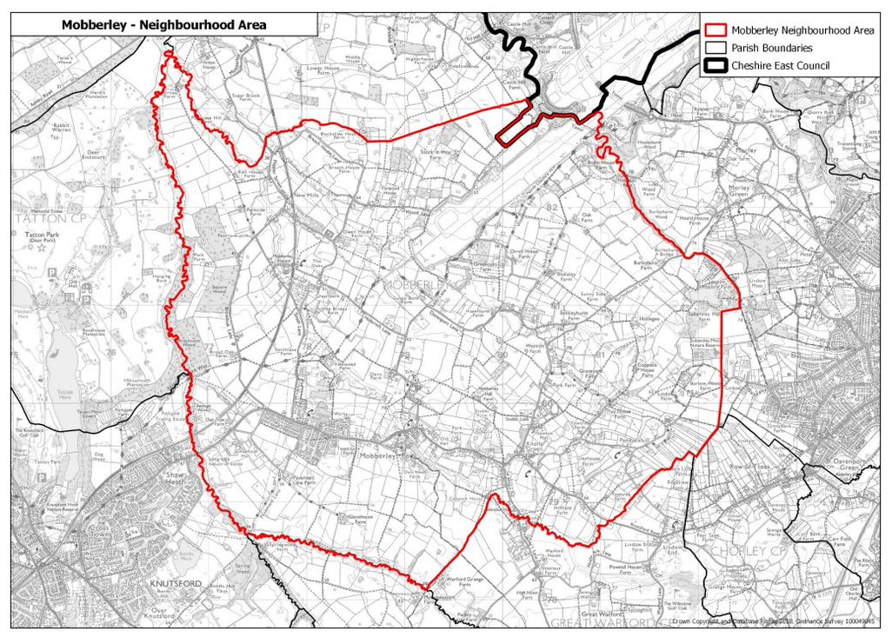

Appendix G - Location of Notice Boards and Defibrillators

Noticeboards
- Outside the Rajar Building
- Layby opposite Moss Lane.

Defibrillators
- The Railway Inn, Station Rd, WA16 6LA
- Plough and Flail, Paddock Hill Lane, WA16 7DB
- Mobberley Methodist Church, Faulkners Lane, WA16 7AJ
- The Victory Hall, Town Lane, WA16 7JQ
- Rajar Building Mobberley, Town Lane, WA16 7ER
- Mossways Park Homes – Morley Green, SK9 5PA

