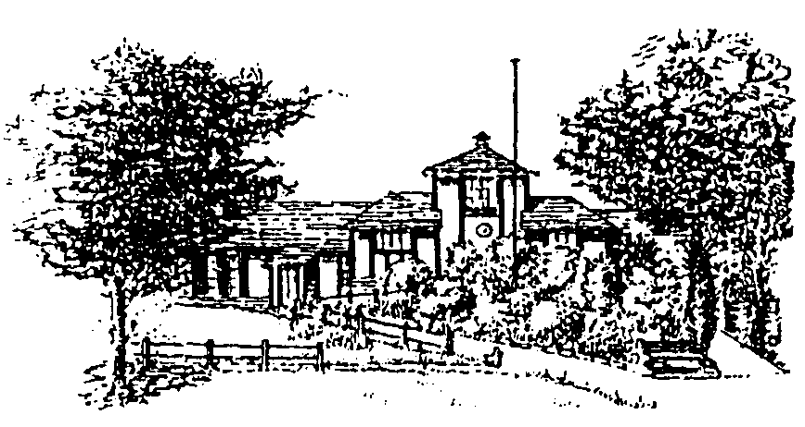
MOBBERLEY PARISH COUNCIL

Rajar Building
Town Lane
Mobberley
Tel: 01565 872333
Email: Clerk@mobberleyparishcouncil.co.uk
www.mobberleyparishcouncil.co.uk

Rajar Committee Meeting Agenda
Monday 25th October 2021 at 19:00

The next Rajar Committee meeting of the Parish Council is planned for 19:00 Monday 25th October 2021 at the Rajar Building. Should you have any items you wish to add to the agenda please submit them to the Clerk by Thursday 21st October.

Agenda:

- Apologies for absence

- To note any declaration(s) of interest.

- To approve and sign the minutes of the meeting held on 5th August 2021.

- To discuss any reports that are due or outstanding.

- Risk Assessment.

- Fire Alarm Checks.

- To discuss any immediate actions that are necessary.

- To discuss future plans for the building.

- Any Other Business.

Next meeting: …Monday 14th February 2022………

Signed……………………………………………………

