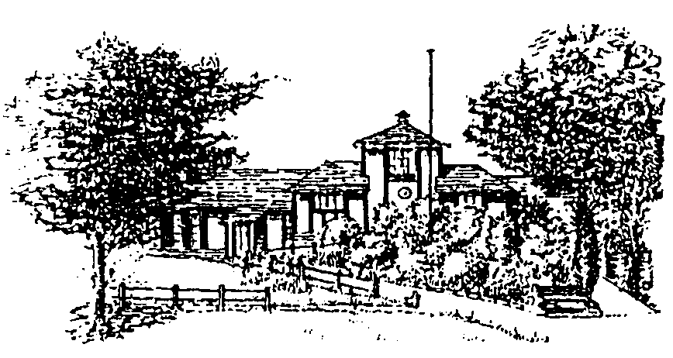
MOBBERLEY PARISH COUNCIL

Rajar Building
Town Lane
Mobberley
Tel: 01565 872333
Email: Clerk@mobberleyparishcouncil.co.uk
www.mobberleyparishcouncil.co.uk

Finance Committee Meeting Agenda
At the Rajar Building Wednesday 13th October 2021 at 19:00

The next Finance Committee meeting of the Parish Council is planned for 19:00 Wednesday 13th October 2021. Should you have any items you wish to add to the agenda please submit them to the clerk by Monday 11th October.

Agenda:

- To nominate a Chairman for the remainder of the year.
- Apologies for absence

- To note any declaration(s) of interest.

- Review 2020/21 budget position.

- To discuss the budget proposal for 2022/23 in order for this to be finalised at the full council meeting on the 1st November 2021.

- To agree the precept for 2022/23 in order for this to be finalised at the full council meeting on the 1st November 2021.

- To discuss the VAT reclaim.

Next meeting: …24th January 2022 at 7pm.…………………………………………

Signed……………………………………………………

